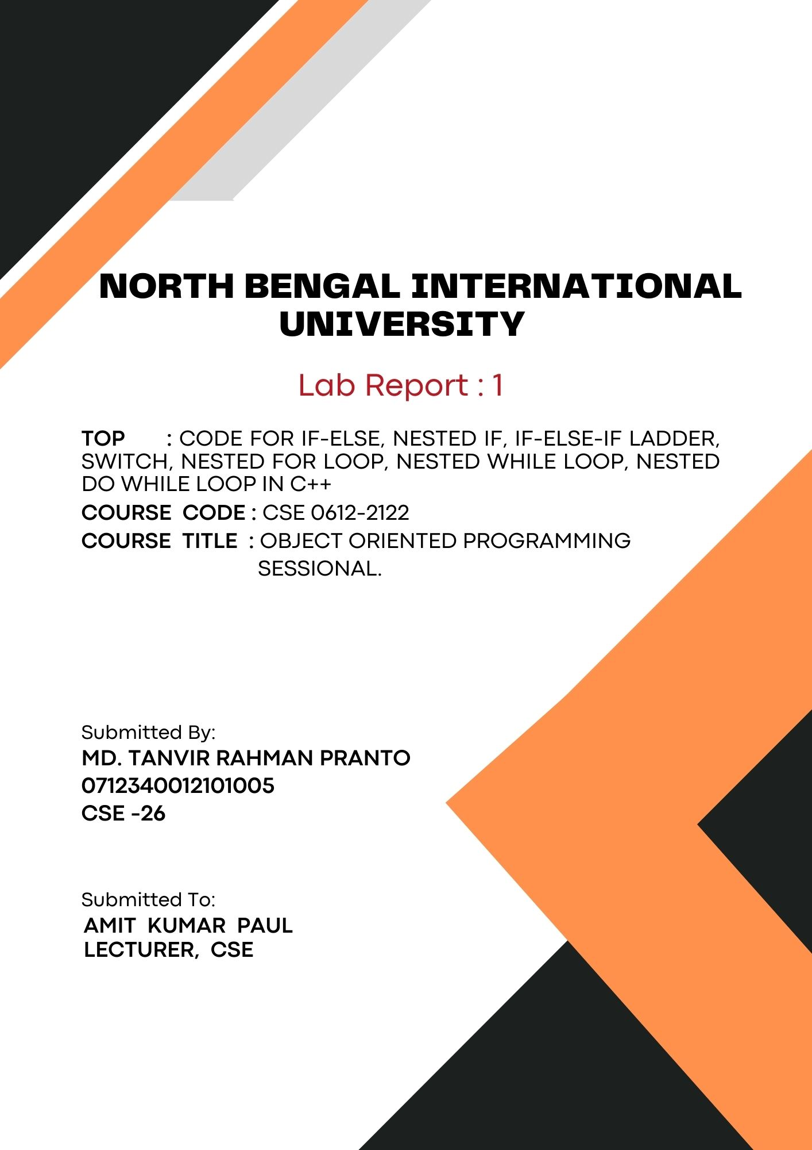
1

Code for if-else, Nested if, if-else-if ladder, switch, Nested for loop, Nested
while loop, do while loop in c++

# if-else:
Code:
#include <iostream>

int main() {
int number;
std::cout << "Enter a number: ";
std::cin >> number;

if (number > 10) {
std::cout << "The number is greater than 10." << std::endl;
} else {
std::cout << "The number is 10 or less." << std::endl;
}

return 0;
}
Output:
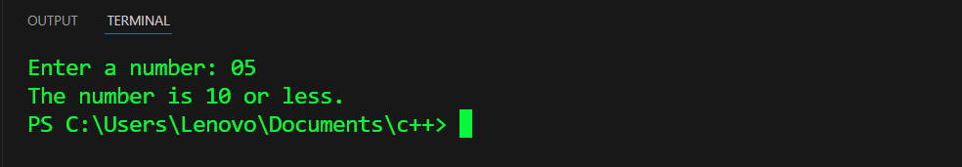

# Nested if:
Code:
#include <iostream>

int main() {
int number;
std::cout << "Enter a number: ";
std::cin >> number;

if (number > 0) {
std::cout << "The number is positive." << std::endl;
if (number % 2 == 0) {
std::cout << "It is even." << std::endl;
} else {
std::cout << "It is odd." << std::endl;
}
} else if (number < 0) {
std::cout << "The number is negative." << std::endl;
} else {
std::cout << "The number is zero." << std::endl;
}
return 0;
}
Output:
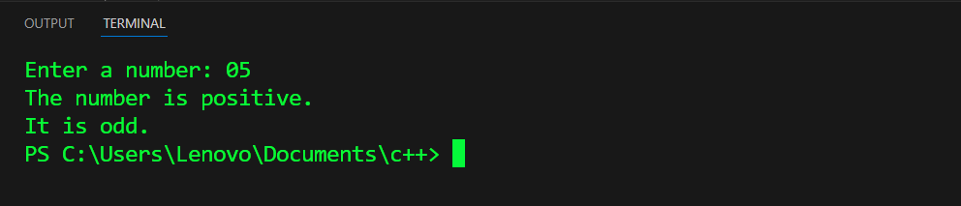

# if-else-if ladder:
Code:
#include <iostream>

int main() {
int age;
std::cout << "Enter your age: ";
std::cin >> age;

// If-else-if ladder
if (age >= 65) {
std::cout << "You are a senior citizen." << std::endl;
} else if (age >= 18) {
std::cout << "You are an adult." << std::endl;
} else if (age >= 13) {
std::cout << "You are a teenager." << std::endl;
} else {
std::cout << "You are a child." << std::endl;
}

return 0;
}

Output:
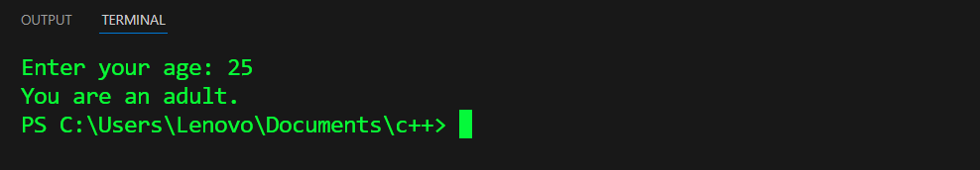

# Switch:
Code:
#include <iostream>

int main() {
char grade;
std::cout << "Enter your grade (A, B, C, D, F): ";
std::cin >> grade;

switch (grade) {
case 'A':
std::cout << "Excellent!" << std::endl;
break;
case 'B':
std::cout << "Good job!" << std::endl;
break;
case 'C':
std::cout << "Well done!" << std::endl;
break;
case 'D':
std::cout << "You passed." << std::endl;
break;
case 'F':
std::cout << "Better luck next time." << std::endl;
break;
default:
std::cout << "Invalid grade!" << std::endl;
break;
}

return 0;
}

Output:
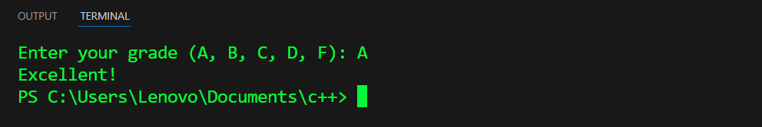

# Nested for loop:
Code:
#include <iostream>

int main() {

int n = 5;
for (int i = 1; i <= n; ++i) {
for (int j = 1; j <= i; ++j) {
std::cout << "* ";
}
std::cout << std::endl;
}

return 0;
}
Output:
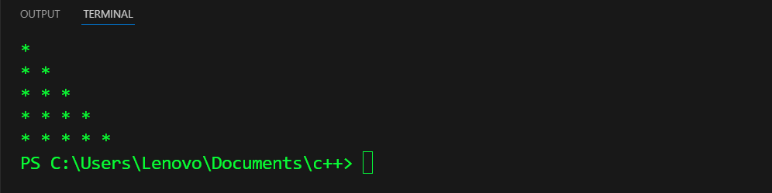

# Nested While loop:
Code:
#include <iostream>

int main() {
int i = 1;
int j;

while (i <= 5) {
j = 1;
while (j <= i) {
std::cout << j << " ";
++j;
}
std::cout << std::endl;
++i;
}

return 0;
}

Output:
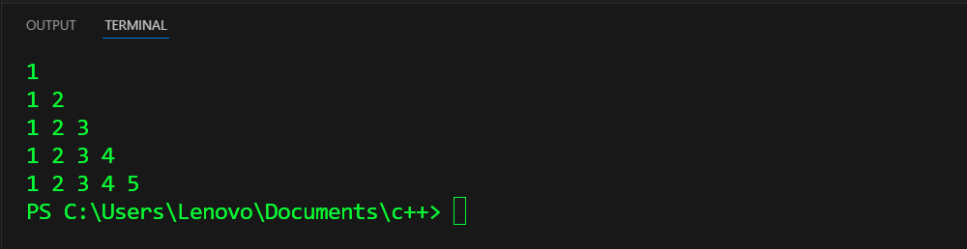

# Nested While loop:
Code:
#include <iostream>
int main() {
int row = 1;
int col;

do {
col = 1;
do {
std::cout << row * col << "\t";
++col;
} while (col <= 5);
std::cout << std::endl;
++row;
} while (row <= 5);
return 0;
}
Output:
